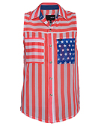 | - Celebrate Independence with the Liberty Women's Tank from Hurley!  - Link: http://www.awin1.com/cread.php?awinmid=5356&awinaffid=!!!id!!!&clickref=&p=https%3A%2F%2Fshop.hurley.com%2Fdepartment%2Ftops-10021.cfm%3Fkillnav%3D1%26did%3D10021
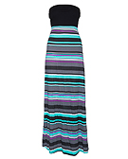 | - Keep it light with the Nalu Womens Dress from Hurley starting at $40!  - Link: http://www.awin1.com/cread.php?awinmid=5356&awinaffid=!!!id!!!&clickref=&p=https%3A%2F%2Fshop.hurley.com%2Fdepartment%2Fdresses-10019.cfm%3Fkillnav%3D1%26did%3D10019
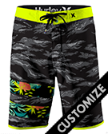 | - The next level of boardshort innovation is here with the Phantom Block Party Warp 2 - Shop here!  - Link: http://www.awin1.com/cread.php?awinmid=5356&awinaffid=!!!id!!!&clickref=&p=https%3A%2F%2Fshop.hurley.com%2Fsite%2Fpc%2F
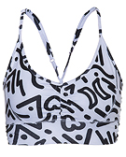 | - New Beach active styles available from Hurley: Take your workout to the beach and beyond with Nike Dri-FIT. Shop here!  - Link: http://www.awin1.com/cread.php?awinmid=5356&awinaffid=!!!id!!!&clickref=&p=https%3A%2F%2Fshop.hurley.com%2Fdepartment%2Fbeach-active-10226.cfm%3Fkillnav%3D1%26did%3D10226
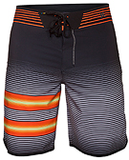 | - The most advanced boardshorts on the market. Phantom Fuse 2 boardshorts available at Hurley.com - shop Now!  - Link: http://www.awin1.com/cread.php?awinmid=5356&awinaffid=!!!id!!!&clickref=&p=https%3A%2F%2Fshop.hurley.com%2Fdepartment%2Fboardshorts-10031.cfm%3Fkillnav%3D1%26did%3D10031

